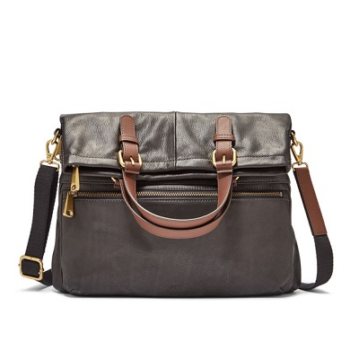

Explorer Tote

PRODUCT DETAILS

**Silhouette: Tote**

**Tech Compatibility: iPhone® 7**

**Exterior Material: Leather/Polyurethane Trim**

**Interior Details: 1 Zipper Pocket, 2 Media Pockets**

**Measurements: 13"L x 2"W x 15"H**

**Handles/Straps: 2 Grab Handles, 1 Detachable and Adjustable Shoulder Strap**